The School District City of Erie, PA

**April 2025**

Bidder Must Deposit With

Bid – **CERTIFIED CHECK** Or

BID BOND 5% of Total Bid

**BID ON –** VF-2SS CNC Machine with Associated Delivery, Installation, Training and Simulation Module

The Board of Directors

of the School District

of the City of Erie, PA

Gentlemen:

We, the undersigned, propose to furnish and install the following **BID** VF-2SS CNC Machine with Associated Delivery, Installation, Training and Simulation Module

**:** DOLLARS ($_____________)

Bids shall be sealed and endorsed on the envelope, or on the subject line on electronic submissions, **“**VF-2SS CNC Machine with Associated Delivery, Installation, Training and Simulation Module**”** and delivered to School District of the City of Erie, Administration Building,1910 Sassafras Street, Erie, PA 16502, Board Secretary Office, ATTN: BIDS, by April 25th, 2025 by 11:00 am. Bids shall be delivered in either person, via USPS, a contract carrier such as UPS, FedEx, etc., or via electronic submission to bids@eriesd.org.  Late bids will be rejected.  Bids will be opened utilizing an online format on April 25th, 2025 at 12:30 pm. Award of bid may be made at the regular meeting of the Board onMay 14th, 2025 at 6:00 pm.

The School District will conduct the bid opening utilizing an online format at the date and time identified above. The School District will provide interested proposers with a link to participate in the bid opening. If an interested proposer requires reasonable accommodations to participate in an online format bid opening due to a disability, if the interested proposer wishes to participate in the meeting but does not have internet access, or if a member of the public wishes to view the opening electronically, contact Neal Brokman, Assistant Superintendent, at [nbrokman@eriesd.org](mailto:nbrokman@eriesd.org).

The Board of School Directors will consider accepting the bid of the lowest responsible bidder meeting specifications, kind, quality and material being equal, but shall have the right to reject any and all bids and to waive defects in form. The Board is not obligated to accept the lowest or any other bid.

Respectfully submitted:

**The School District City of Erie, PA**

***Brian J. Polito, CPA District Administration Building***

***Superintendent of Schools 1910 Sassafras Street Erie PA 16502***

GENERAL CONDITIONS

Bids shall be submitted on the Bidding Blank attached hereto, and should be submitted through the means identified on the Bidding Blank.

No bids will be entertained unless accompanied by a deposit, as a **CERTIFIED CHECK or BID BOND** in the amount of five per cent (5%) of the total bid, made payable to The School District City of Erie and enclosed in the envelope containing the bid.

No bid received can be withdrawn prior to the close of the regular meeting of the Board of School Directors next succeeding the opening of the bids. Bidder agrees that the School District of the City of Erie shall have up to sixty (60) days to accept or reject the bid and bidder agrees that the bid quote shall remain open for that period. The Board of School Directors may reject any bid, or portion of any bid, for any reason or no reason.

The special attention of the bidders is directed to the fact that no claims for relief on account of mistakes or omissions in the bidding will be considered and the contractors will be held strictly to their bids, or, alternatively, and at the sole discretion of the Board of School Directors, their deposit may be forfeited. In addition to other remedies available to the School District, the deposit shall be forfeited if the successful bidder fails to execute an agreement or perform as required.

**Standard of Quality**: The specific mention of a manufacturer’s name shall be understood to indicate a standard of quality or design, and not as limiting competition thereon or excluding other goods equal in every respect to the materials or goods specified in the opinion of the Controller or his designee. If you do not bid on our specifications as listed, please fill in manufacturer’s name and model number of items you intend to furnish as an equal alternate. The Career and Technical Educational Director, or his designee, shall determine, in his sole discretion, whether the alternate item is an approved equal.

Bidders are to submit prices on both the rate and the total. Bidders please indicate length of time prices will remain firm. If a “Rate” is given on an item, a “Total” must be given on the item. Awards may be made item by item and bidders hereby agree to furnish the items awarded to them. All supplies furnished upon the contract not up to specifications will be rejected.

All charges for transportation, freight, express and parcel post are to be paid by the successful bidder. It is understood that the bidder agrees to deliver any items on which bids are accepted.

Completion of contract shall not exceed sixty days after award is made. The successful bidder will be required to execute a contract with the School District if identified as the apparent low bidder. A fully executed contract must be received by the School District prior to final award by the Board of School Directors. The form of the contract is enclosed with this bid packet.

All items to be delivered to the Erie High School. If you have any questions, please contact Jason Burgert, Career and Technical Education Director at 814-874-6225 or [jburgert@eriesd.org](mailto:jburgert@eriesd.org).

**SPECIFICATIONS**

The following specifications are approved by the Board of Directors for purchase or approved equal as approved by the Career and Technical Education Director.

**VF-2SS WITH SIMULATOR**

**PROPOSAL**

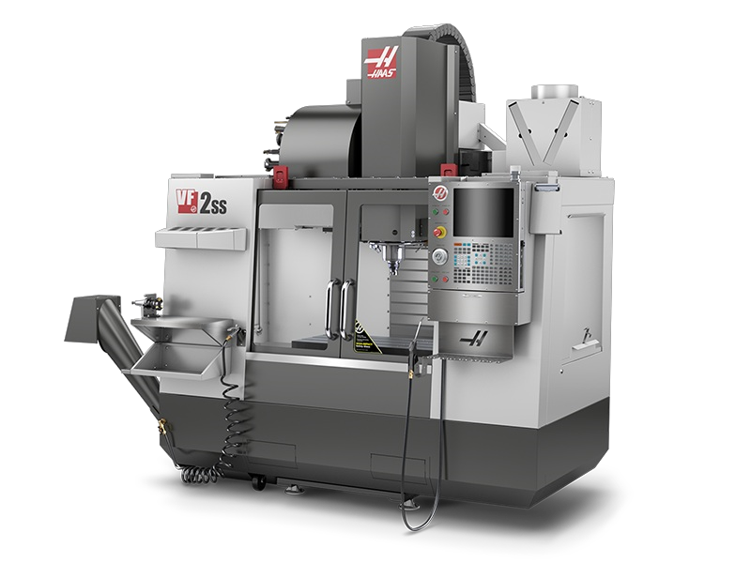

Super-Speed CNC Vertical Machining Center with 30" x 16" x 20" (762 x 406 x 508 mm) travels

**STANDARD FEATURES VF-2SS**

CT option

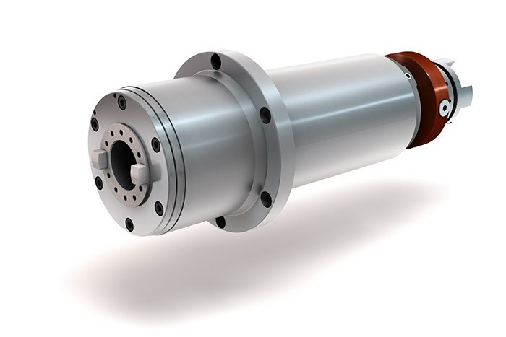12,000-rpm Spindle, 40 taper, 30 hp (22.4 kW) vector drive, inline directdrive. NOTE: Speeds higher than 10,000 rpm require toolholders balanced to a G2.5 rating at a speed greater than or equal to the operational rpm.

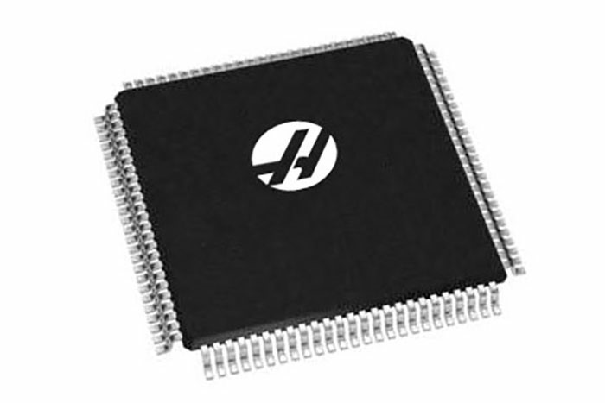Standard Program Memory; 1 GB of onboard memory for program storage and backup.

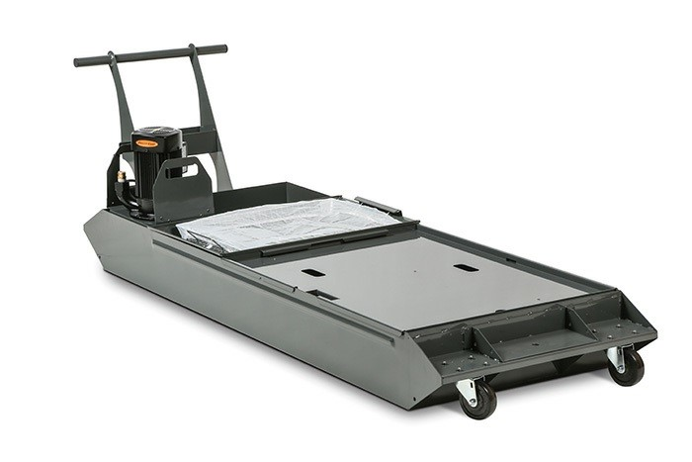55-Gallon (208 liter) Coolant Tank with pump; features a multi-section labyrinth design that prevents chips from reaching the coolant pump.

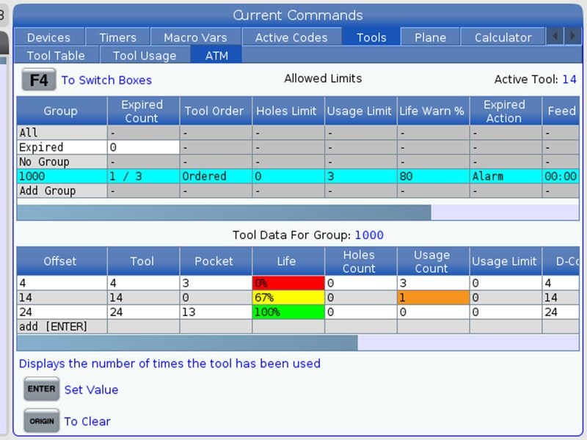Advanced Tool Management is an integrated Advanced Tool Manager in the Haas control that allows you to create a group of redundant tools for use within a program.

Early Power-Failure Detection Module; senses a power failure or severe drop in incoming line voltage and quickly brings all axis motion to a safe and controlled stop.

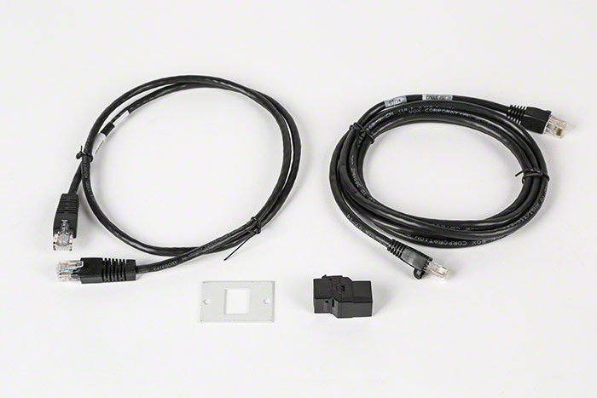Ethernet Interface; allows you to easily transfer files to and from the machine over a local wired network.

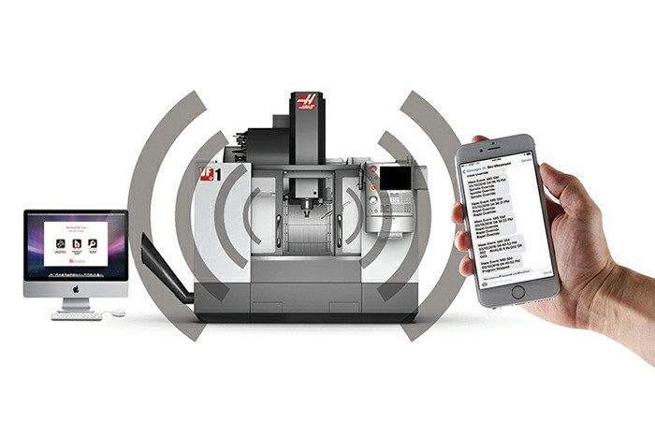HaasConnect: Remote monitoring of your Haas machine. Requires the machine to be connected to the Internet.

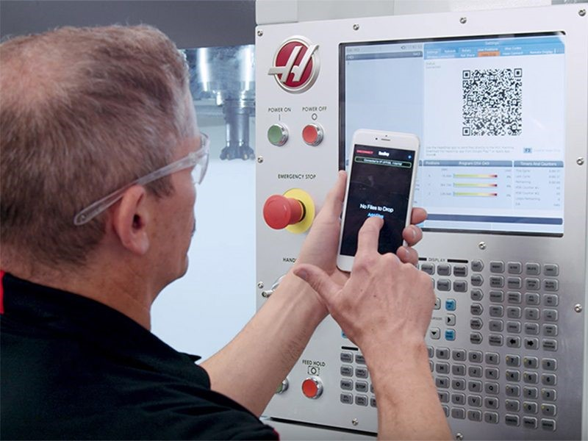HaasDrop Wireless File Transfer is a fast and convenient method for sending images, videos, and even program files from a mobile device directly to the Next-Generation Control on a Haas CNC machine. Available for Android and iOS devices.

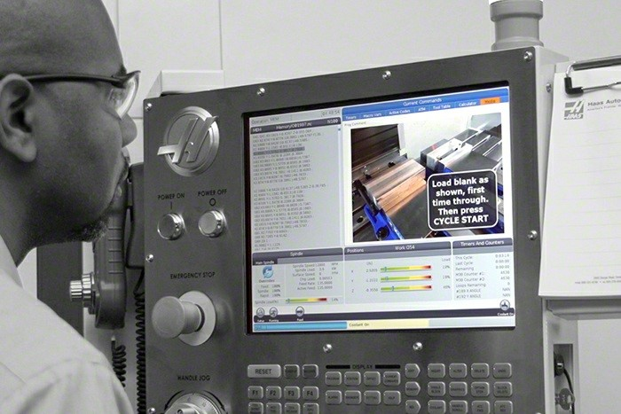Media Display M-Code; M130 is used within an NC program to call up media files (images, videos, PDF files) from memory and display them on the control screen as the program runs. NextGen Control only.

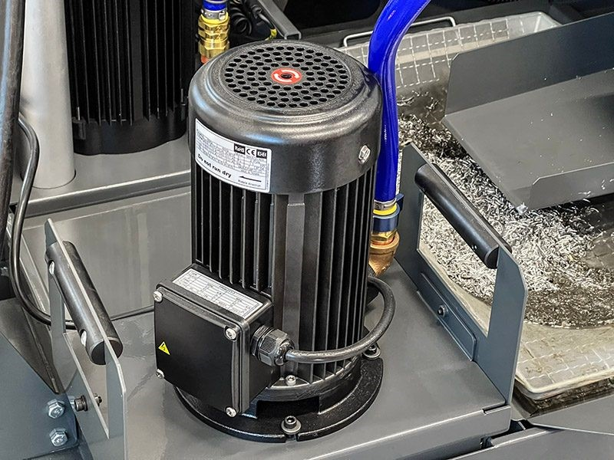Multi-Stage Coolant Pump; 1.5 hp (1.1 kW) pump provides 16 gpm @ 70 psi (61 L/min @ 4.8 bar) @ 60Hz. Offers more flow and higher pressure than the single-stage coolant pump, while offering quieter operation.

Rigid Tapping; synchronized tapping, with built-in tap cycles and up to 8X retract speed.

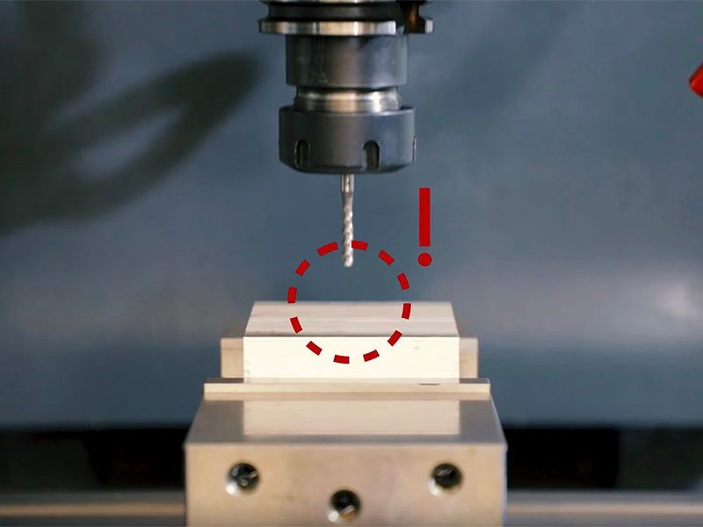Safe Run; a software feature in the Haas control that reduces the chances of significant machine damage during a machine crash.

High-Speed Side-Mount Tool Changer, 40 taper, 30+1 tools 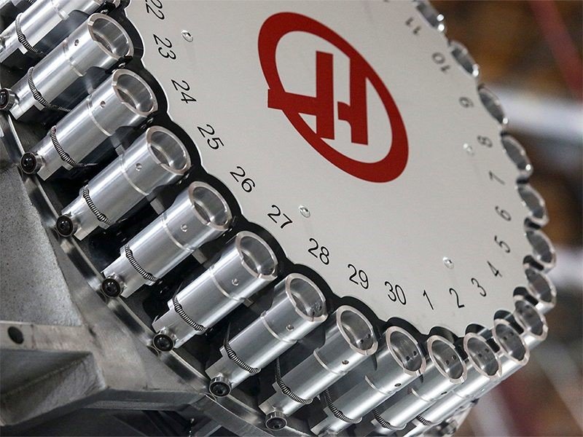

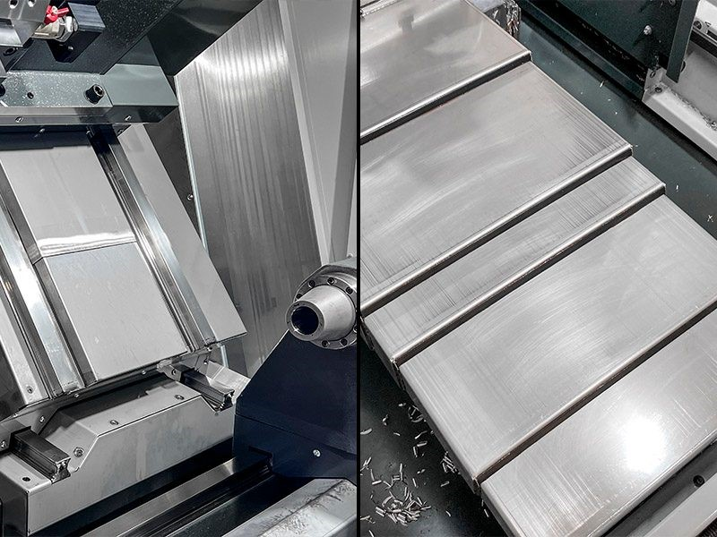Stainless steel way covers; constructed of heavy-gauge 304 stainless steel, with aluminum wipers.

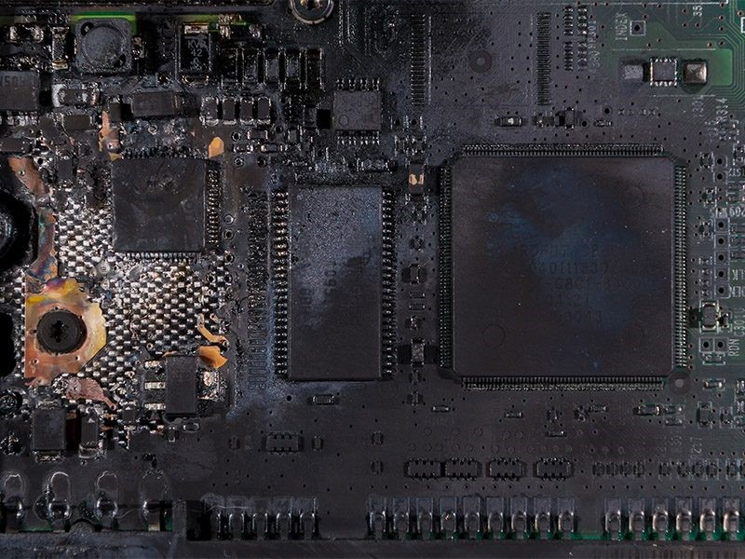Surge Protection; provides protection from power surges to the machine control, preventing damage to critical components. If the machine experiences a power surge, the single-use surge-protection module is consumed, preventing the electrical spike from affecting the rest of the control components. Replacement surge-protection modules are available from Haas. Standard on 3-phase machines only.

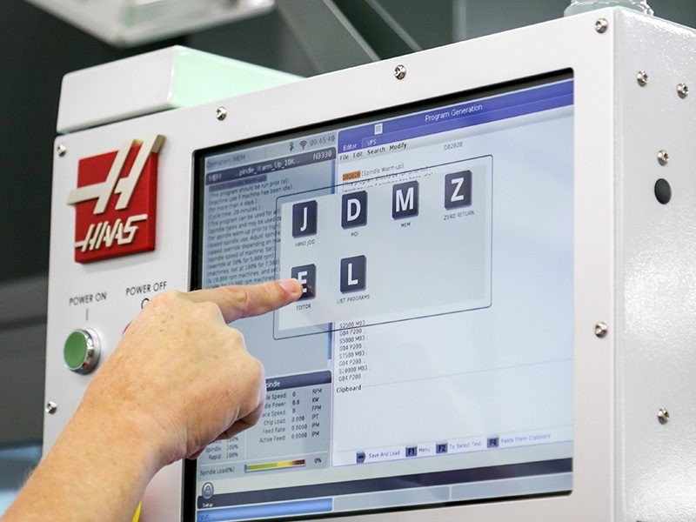Touch Screen interface for the Haas control; allows screen navigation, data entry, and other control functions on-screen, without using the keypad.

WiFi Connection for the Haas Control; provides wireless connectivity between the Haas control and a local area network.

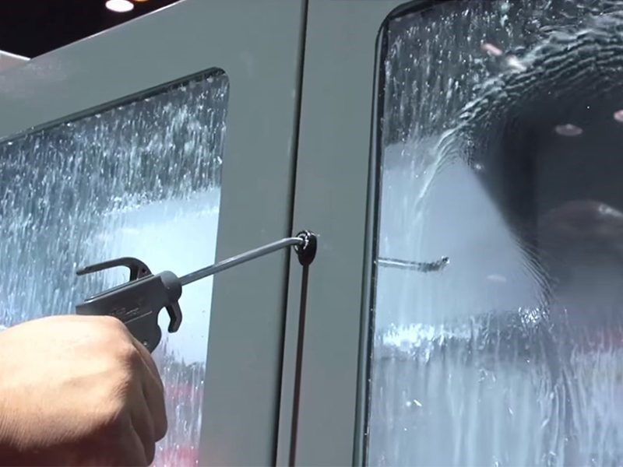Haas Window Blast; airgun-activated feature for clearing coolant from the machine’s window during machining.

Internal Low-Voltage Transformer for 195-260V operation. 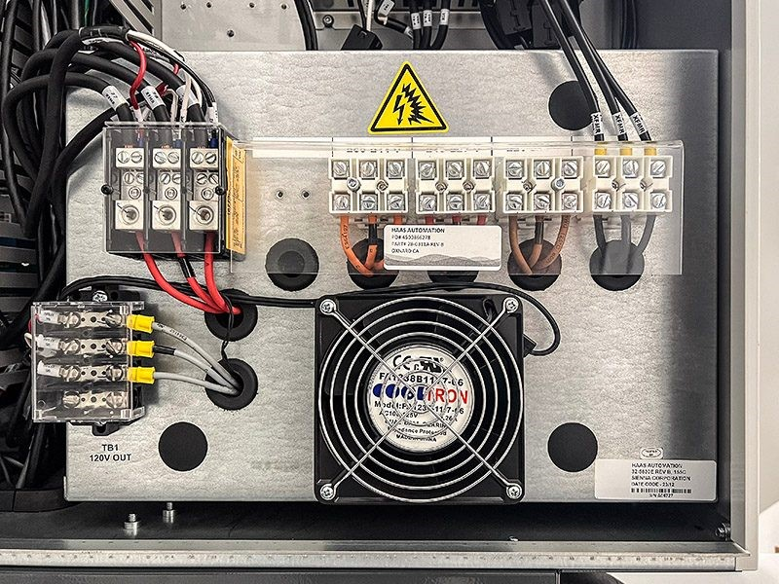

-

**SELECTED OPTIONS VF-2SS**

Wireless Intuitive Probing System

Wireless Intuitive Probing System; Renishaw. Includes the Haas Visual

Programming System, macros, spindle orientation, and coordinate rotation

and scaling.

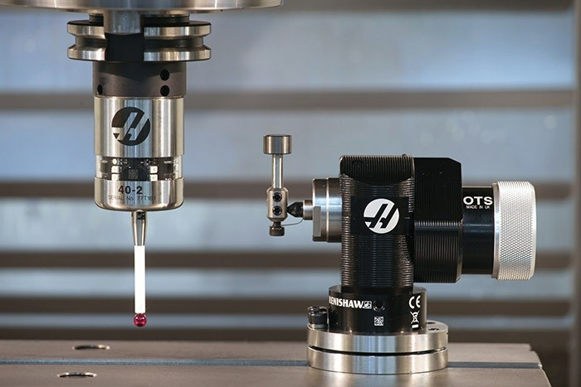

# Chip Auger

Chip Auger; automatically removes chips from the machine, while compressing them and wringing out the coolant.

# Programmable Coolant Nozzle

Programmable Coolant Nozzle; a multi-position nozzle that automatically directs coolant precisely at the cutting tool.

# High-Speed Machining

High-Speed Machining; allows faster feedrates and more complex toolpaths, without hesitation or starving the machine.

# 1-Year Extended Warranty

1-Year Extended Warranty (includes 1-year standard warranty); adds another full year to your warranty, parts and labor.

-

**SPECS VF-2SS**

|  |  |  |
| --- | --- | --- |
| **Travels** | **S.A.E** | **Metric** |
| **X Axis** | 30.00 in | 762 mm |
| **Y Axis** | 16.00 in | 406 mm |
| **Z Axis** | 20.00 in | 508 mm |
| **Spindle Nose to Table (~ max)** | 24.0 in | 610 mm |
| **Spindle Nose to Table (~ min)** | 4.0 in | 102 mm |
| **Spindle** | **S.A.E** | **Metric** |
| **Max Rating** | 30.0 hp | 22.4 kW |
| **Max Speed** | 12000 rpm | 12000 rpm |
| **Max Torque** | 90.0 ft-lbf @ 2000 rpm | 122.0 Nm @ 2000 rpm |
| **Drive System** | Inline Direct-Drive | Inline Direct-Drive |
| **Taper** | CT40 | BT40 | HSK-A63 | CT40 | BT40 | HSK-A63 |
| **Bearing Lubrication** | Air / Oil Injection | Air / Oil Injection |
| **Cooling** | Liquid Cooled | Liquid Cooled |
| **Table** | **S.A.E** | **Metric** |
| **Length** | 36.0 in | 914 mm |
| **Width** | 14.0 in | 356 mm |
| **T-Slot Width** | 0.626 in to 0.630 in | 15.90 mm to 16.00 mm |
| **T-Slot Center Distance** | 4.92 in | 125 mm |
| **Number of Std T-Slots** | 3 | 3 |
| **Max Weight on Table (evenly distributed)** | 1500 lb | 680 kg |
| **Feedrates** | **S.A.E** | **Metric** |
| **Max Cutting** | 833 ipm | 21.2 m/min |
| **Rapids on X** | 1400 ipm | 35.6 m/min |

|  |  |  |
| --- | --- | --- |
| **Rapids on Y** | 1400 ipm | 35.6 m/min |
| **Rapids on Z** | 1400 ipm | 35.6 m/min |
| **Axis Motors** | **S.A.E** | **Metric** |
| **Max Thrust X** | 1995 lbf | 8874 N |
| **Max Thrust Y** | 1995 lbf | 8874 N |
| **Max Thrust Z** | 3085 lbf | 13723 N |
| **Tool Changer** | **S.A.E** | **Metric** |
| **Type** | SMTC | SMTC |
| **Capacity** | 30+1 | 30+1 |
| **Max Tool Diameter (full)** | 2.5 in | 64 mm |
| **Max Tool Diameter (adjacent empty)** | 5.0 in | 127 mm |
| **Max Tool Length (from gage line)** | 11 in | 279 mm |
| **Max Tool Weight** | 12.0 lb | 5.4 kg |
| **Tool-to-Tool (avg)** | 1.80 s | 1.80 s |
| **Chip-to-Chip (avg)** | 2.40 s | 2.40 s |
| **General** | **S.A.E** | **Metric** |
| **Coolant Capacity** | 55 gal | 208 L |
| **Air Requirements** | **S.A.E** | **Metric** |
| **Air Required†** | 4 scfm @ 100 psi | 113 L/min @ 6.9 bar |
| **Inline Air Hose** | 3/8 in | 3/8 in |
| **Coupler (Air)** | 3/8 in | 3/8 in |
| **Air Pressure Min** | 80 psi | 5.5 bar |
| **Electrical Specification** | **S.A.E** | **Metric** |
| **Spindle Speed** | 12000 rpm | 12000 rpm |
| **Drive System** | Inline Direct-Drive | Inline Direct-Drive |

|  |  |  |
| --- | --- | --- |
| **Spindle Power** | 30.0 hp | 22.4 kW |
| **Input AC Voltage (3 Phase) - Low** | 220 VAC | 220 VAC |
| **Full Load Amps (3 Phase) - Low** | 70 A | 70 A |
| **Input AC Voltage (3 Phase) - High\*** | 440 VAC | 440 VAC |
| **Full Load Amps (3 Phase) - High\*** | 35 A | 35 A |
| **Dimensions - Shipping** | **S.A.E** | **Metric** |
| **Domestic Pallet** | 101.0 in x 99.0 in x 101.0 in | 257 cm x 251 cm x 257 cm |
| **Export Pallet** | 98.0 in x 91.5 in x 100.0 in | 249 cm x 232 cm x 254 cm |
| **Weight** | 7800 lb | 3539.0 kg |
| **Domestic Pallet w/Conveyor** | 124 in x 101 in x 105 in | 315 cm x 257 cm x 265 cm |
| **Weight w/Conveyor** | 8380 lb | 8380 lb |

# **PRODUCT OVERVIEW SIMULATOR**

SIMULATOR

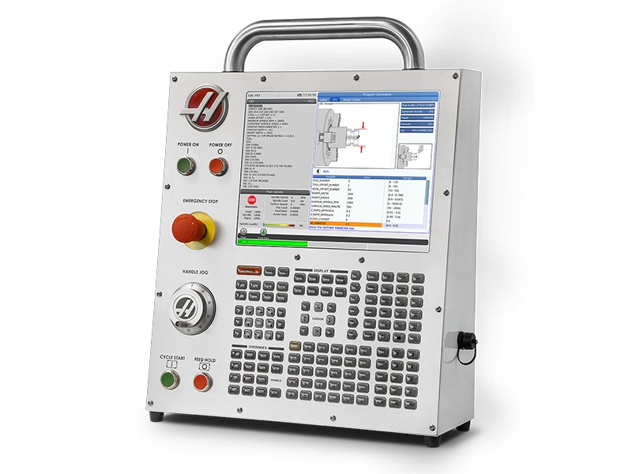

Control Simulator Module, Next Generation Control; dual software (mill & lathe); perfect for classroom training and on-site demonstrations.

# **SPECS SIMULATOR**

|  |  |  |
| --- | --- | --- |
| **Dimensions - Shipping** | **S.A.E** | **Metric** |
| **Export Crate** | 29.0 in x 23.5 in x 11.0 in | 74 cm x 60 cm x 28 cm |
| **Weight** | 35 lb | 16.0 kg |

NAME OF VENDOR

ADDRESS

CONTACT PERSON

TELEPHONE NUMBER

First, the undersigned having carefully examined the **VF-2SS CNC Machine with Associated Delivery, Installation, Training and Simulation Module** in accordance with the specifications of the proposal, submits this proposal and agrees to furnish and perform the specified **VF-2SS CNC Machine with Associated Delivery, Installation, Training and Simulation Module** for the School District of the City of Erie for the amounts indicated on page 1 of the Bid.

Second, the undersigned agrees to enter into a written contract to furnish such materials and services as required in the proposal specifications.

Third, the following quotation prices are listed as firm for a period of __________ after the due date of this request for bid.

**NOTE: The School District of the City of Erie will not be liable and will not pay for any applicable costs not included and detailed in the Bid.**

Signature

Date

Title or Office

**INSTRUCTIONS FOR NON-COLLUSION AFFIDAVIT**

1. This Non-Collusion Affidavit is material to any contract awarded pursuant to this RFP. According to the Pennsylvania Antibid-Rigging Act. 73 P.S. 1611 et seq. governmental agencies may require Non-Collusion Affidavits to be submitted together with bids or RFP’s.
2. This Non-Collusion Affidavit must be executed by the member, officer or employee of the Vendor who makes the final decision on prices and amounts quoted in the RFP.
3. Bid/RFP rigging and other efforts to restrain competition, and the making of false sworn statements in connection with the submission of bids or RFP’s are unlawful and may be subject to criminal prosecution. The person who signs the affidavit should examine it carefully before signing and assure himself/herself that each statement is true and accurate, making diligent inquiry, as necessary, of all other persons employed by or associated with the Vendor with responsibilities for the preparation, approval, or submissions of the RFP.
4. In case of a RFP submitted by a joint venture, each party to the venture must be identified in the RFP/Bid documents, and an affidavit must be submitted separately on behalf of each party.
5. The term “complementary RFP” as used in the Affidavit has the meaning commonly associated with that term in the bidding/RFP process, and includes the knowing submission of RFP’s higher than the RFP of another Vendor, any intentionally high or noncompetitive RFP, and any other form of RFP submitted for the purpose of giving a false appearance of competition.
6. Failure to file an Affidavit in compliance with these instructions will result in disqualification of the RFP.

**NON-COLLUSION AFFIDAVIT**

**BID ON –** VF-2SS CNC Machine with Associated Delivery, Installation, Training and Simulation Module

State of

County of

I state that I am of

(Title) (Name of Vendor)

and that I am authorized to make this affidavit on behalf of my company, and its owners, directors, and officers, I am the person responsible in my company for the price(s) and the amount of this Request for Proposal (RFP).

I state that:

1. The price(s) and amount of this RFP have been arrived at independently and without consultation, communication, or agreement with any other Vendor.
2. Neither the price(s) nor the amount of this RFP, and neither the approximate price(s) nor the approximate amount of this RFP, have been disclosed to any other Vendor, and they will not be disclosed before the RFP submission to The School District of the City of Erie.
3. No attempt has been made or will be made to induce any Vendor or person to refrain from submitting an RFP to The School District of the City of Erie, or to submit an RFP higher than this RFP, or to submit any intentionally high or noncompetitive RFP or other form of complementary RFP.
4. The RFP of my company is made in good faith and not pursuant to any agreement or discussion with or inducement from, any Vendor or person to submit a complementary or other noncompetitive RFP.
5. , its affiliates, subsidiaries, officers, directors and employees

(Name of my Company)

are not currently under investigation by any governmental agency and have not in the last four years been convicted or found liable for any act prohibited by State or Federal law in any jurisdiction, involving conspiracy or collusion with respect to submitting an RFP to any public entity, except as follows:

I state that understand and acknowledges that the above

(Name of my Company)

representations are material and important, and will be relied on by The School District of the City of Erie when recommending for award the agreement for which this RFP is submitted, I understand and my company understands that any misstatement in this affidavit is and shall be treated as fraudulent concealment from the School District of the City of Erie of the true facts relating to the submission of RFP’s for this agreement.

Signature of Authorized Person

(Print Name of Authorized Person and Company Position)

Sworn to and subscribed before

Me this day of

, 20

(Notary Public) (My Commission Expires)